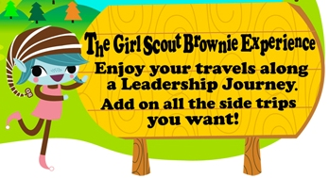
Program Leader(s): XXX
Troop Leaders On-site: XXX
First Aider: XXX
Girl Scout Troop ###
Troop Meeting
DATE
Girls Need to Bring: Their bags, monthly dues

Kaper Duty: XXX Patrol

 | Activity Description | Supplies/Assistance
6:30-6:50  All troop | - Check in  - Community Service Project – making dog and cat braided toys | - Supplies/instructions for pet toy community service project (Activity leader)
6:45-6:50  Opening | Flag Ceremony | - Flag, stand, caller note
6:50-7:55 | Senses Try-it. We will have separate stations (~10 minutes each) for:  - Look around – Kim’s game. Look at 10 objects on a table, cover them up, and see how many of them you can remember  - Listen to the World. Listen to 3 different sounds with and without the plugs in to see how people with hearing problems might hear things  - Put Your Nose to Work. Blindfold a scout, then holding a strong smelling object, see if they can follow you around the room  - Take a Taste Test. Taste a salty, sweet, bitter, and sour food. Which did you like best and why? Do any foods have more than one flavor?  - Touch and Feel. Try Braille. Find some Braille writing around our meeting room and see how it feels. Write your name in Braille. | - 10 objects to look at and a sheet  - Ear plugs, music  - Lemon  - Salty, sweet, bitter, and sour food  - Braille alphabet, paper, and pencil
7:55-8:00  Whole troop | Friendship squeeze | 