THE SUPER MARIO NEWS TIME
Your best Newspaper for Super Mario News!!!!
This is a newspaper written by the Super Mario News Central, a wiki site and this is non-profit material all info and images go to Nintendo!

Welcome to the first edition!!!
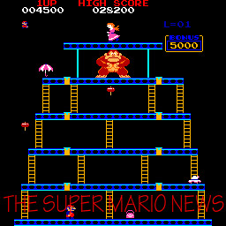
HEADLINE HEADLINES
Watch out for our daily headlines on this printable newspaper!!!

Why this newspaper was made!!!
This newspaper was made to dedicate Super Mario, The Hero of the video game history!!! 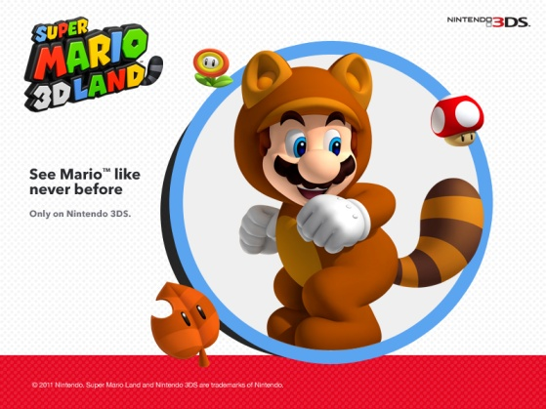
This newspaper will look back and go into the future of what happened and what is happening with the beloved Video Game Character! Enjoy as our multi-paged Newspaper commences with a Blast!!!!

Reviews
Watch as this newspaper reviews game and rates them look out about this part of the page every week or so for a Video Game Review!!!
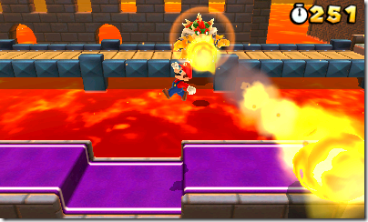

Current Events
If there is anything special event that is going to happen, we will report on it here.
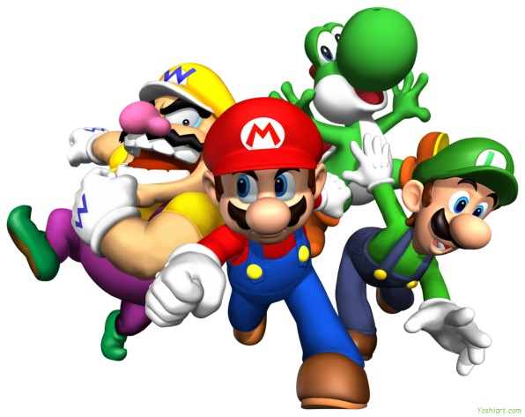

Mario Current Events
These are some imaginative ideas on what could be happening in Mario’s World
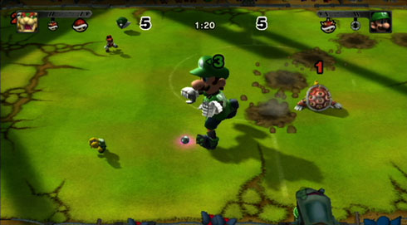

AND LUIGI IS ABOUT TO GO FOR THE GOAL!!!

THIS IS ONLY THE FIRST EDITION AND THE SECOND ONE WILL INCLUDE MUCH MORE INFO SO READ UP!!!!

