Planet Information
Name of the planet: | Size of the planet:  - a little smaller than Earth  - the same size as Earth  - a little bigger than Earth | Gravity of the planet:  - weaker than on Earth  - the same as on Earth  - stronger than on Earth
 | Environment of the planet:  a. desert b. jungle  c. ocean d. ice  e. ___________________ | Life on the planet:  a. no life b. only plant life  c. plant and animal life  d. plant, animal, & intelligent life
 | How (many hours) long is the planet’s “day”?  a. 13 hours b. 9 hours  c. 47 hours d. ___ hours | How many moons does the planet have?  a. no moons b. one moon  c. two moons d. ___ moons

Astronaut Information
How many people are in the crew of your ship?  - six  - twenty  - eighty  - four hundred  - ___________ | What did you bring with you to the planet? | What is your mission?  - build a colony  - research the environment  - observe the planet’s life  - ____________________  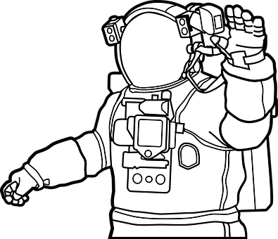
What is your job?
a. Captain b. Scientist
c. Engineer d. Doctor
e. Teacher f. Farmer
g. _____________

Brainstorming
Journal
Imagine you have lived for one week on your new planet. Write a journal about the experience.
Use AT LEAST 10 of the following words/phrases from Lesson 4.
Circle the words you use below and underline them in your journal.
operate 稼働する  gravity 重力  condition(s) 状態  carry out ～を行う  observation 観測  universe 宇宙  take advantage of ～を活用する | harsh 過酷な  somehow どうにかして  maintain 保つ  become accustomed to 慣れた  stress ストレス  lifestyle 生活様式  work out (a problem) 解決するdue to ～が原因で，～のために | be supposed to do ～することになっている, ～と考えられている  boredom 退屈  make do with ～で何とかやりくりする  oxygen 酸素  crew 乗組員  overcome 克服する
It has been one week since we arrived on

Class No. Name

